Day 34 – Quiz program and API practice

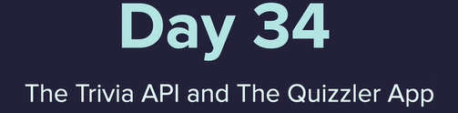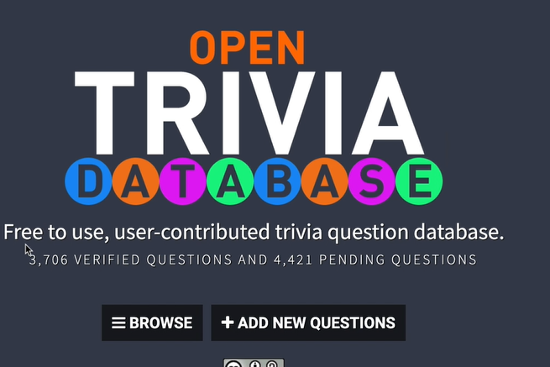

<https://opentdb.com/>

from question_model import Question  
# from data import question_data  
from quiz_brain import QuizBrain  
import requests  
response = requests.get(url="https://opentdb.com/api.php?amount=10&difficulty=easy&type=boolean")  
response.raise_for_status()  
data=response.json()  
# print(data["results"])  
question_data = data["results"]  
  
question_bank = []  
for question in question_data:  
 question_text = question["question"]  
 question_answer = question["correct_answer"]  
 new_question = Question(question_text**,** question_answer)  
 question_bank.append(new_question)  
  
  
quiz = QuizBrain(question_bank)  
  
while quiz.still_has_questions():  
 quiz.next_question()  
  
print("You've completed the quiz")  
print(f"Your final score was: {quiz.score}/{quiz.question_number}")

Correcting html entities

<https://www.w3schools.com/html/html_entities.asp>

<https://www.freeformatter.com/html-escape.html>

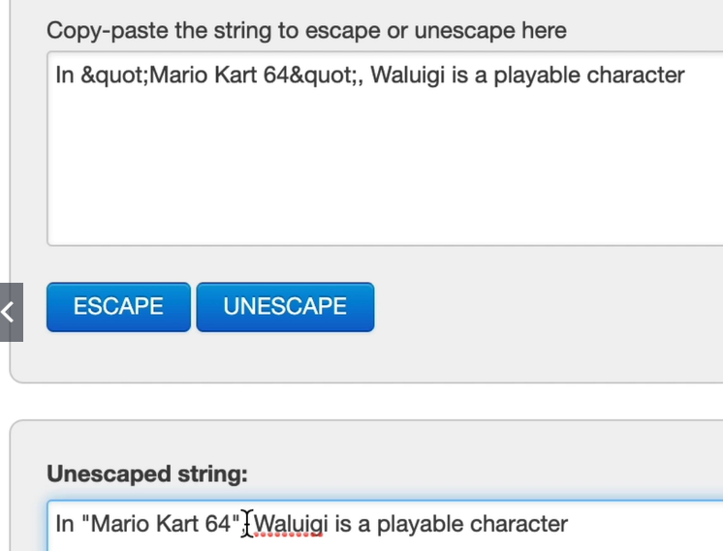

<https://stackoverflow.com/questions/2087370/decode-html-entities-in-python-string>

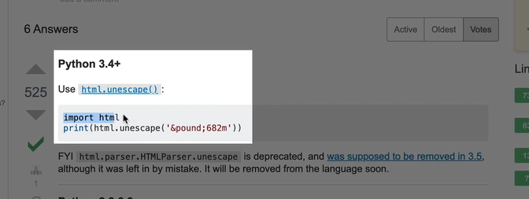

import html  
class QuizBrain:  
  
 def __init__(self**,** q_list):  
 self.question_number = **0** self.score = **0** self.question_list = q_list  
 self.current_question = None  
  
 def still_has_questions(self):  
 return self.question_number < len(self.question_list)  
  
 def next_question(self):  
 self.current_question = self.question_list[self.question_number]  
 self.question_number += **1** q_text = html.unescape(self.current_question.text)  
 user_answer = input(f"Q.{self.question_number}: {q_text} (True/False): ")  
 self.check_answer(user_answer)

create user interface in a class using tkinter

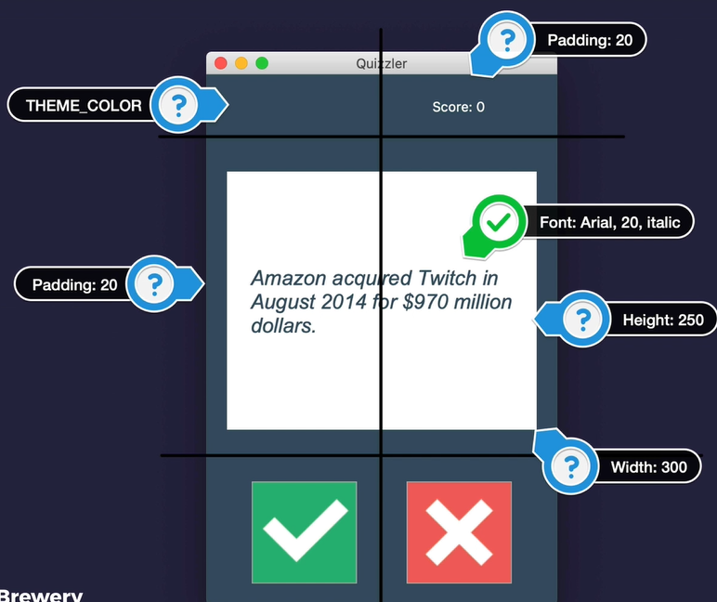

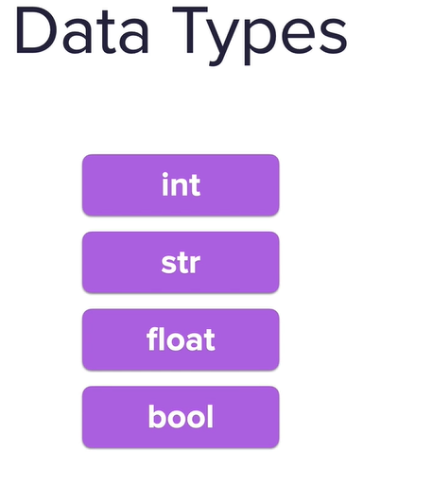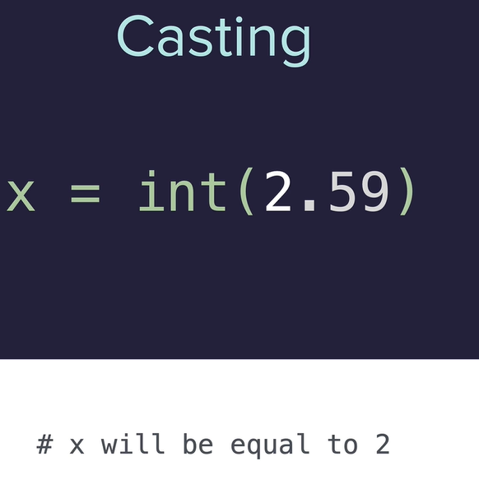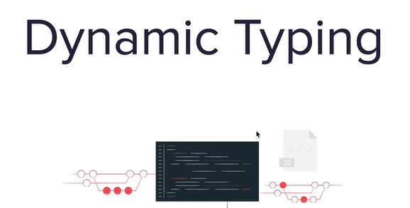

Can declare them

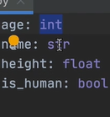

And in a function 